Android Standard Notifications

To create an android standard notification, we need few components:

Notification, TaskStack, PendingIntent, and a NotificationManager.

First off, we need to build a notification using the Notification Builder that takes an activity as an argument:

Notification.Builder mBuilder = **new** Notification.Builder(getActivity())

Then we can add the options that we want to the notification. There are three required options that needs to be added before we build the notification. The three options are:

1. Title
2. Content Text
3. Small Icon.

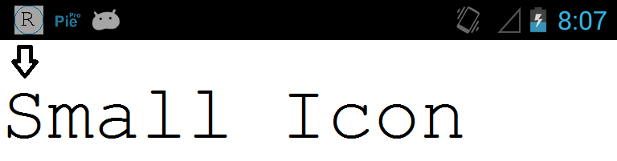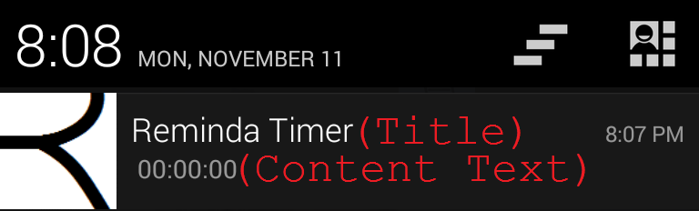

Notification.Builder mBuilder = **new** Notification.Builder(getActivity())

.setSmallIcon(R.drawable.*notification*)

.setContentTitle("Reminda")

.setContentText("Demo")

.setAutoCancel(**true**);

Second, we need to take care of the TaskStack. The task stack mainly takes care of two main things: One, is the where we want to direct the users once they click on the notification. Two, the activity navigation after clicking the back button (Basically, where we want to lead the users once they click on the notification and then the back button).

Intent resultIntent = **new** Intent(mContext, RemindaActivity.**class**);

TaskStackBuilder stackBuilder = TaskStackBuilder.*create*(mContext);

stackBuilder.addParentStack(RemindaActivity.**class**);

stackBuilder.addNextIntent(resultIntent);

PendingIntent resultPendingIntent =

stackBuilder.getPendingIntent(0,

PendingIntent.*FLAG_UPDATE_CURRENT*);

mBuilder.setContentIntent(resultPendingIntent);

Lastly, we need to get the notification manager. And then use it to fire up the built notification. Notice that we also pass it an id. The id is used to reference this notification in case we want to update its contents or dismiss it, etc…

NotificationManager mNotificationManager = (NotificationManager) mContext

.getSystemService(Context.*NOTIFICATION_SERVICE*);

mNotificationManager.notify(mNotificationId, mBuilder.build());